32.26: a) 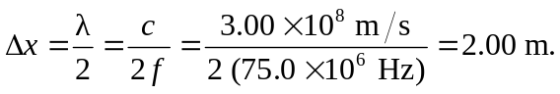
b) The distance between the electric and magnetic nodal planes is one-quarter of a wavelength = 